1. Life quality

Behavioral Risk Factor Data: Health-Related Quality of Life (HRQOL). (2016, May 8). Retrieved September 13, 2016, from

<http://catalog.data.gov/dataset/behavioral-risk-factor-data-health-related-quality-of-life-hrqol>

**Access & Use Information**

[Public:](" \l "accessLevel) This dataset is intended for public access and use.

License: Open Database License (ODbL)

# **Interesting reason:** It’s a dataset that about behavioral risk factor data: health-related quality of life (HRQOL). The research’s surveillance is used to identify unmet population health needs including recognizing trends, disparities, and determinants of health in the population. It combines the behavior and health I think the idea is interesting and useful.

# **Potential data users and decision-makers for this data:** Centers for Disease Control and Prevention; general public who is care about healthy life.

**Three questions this data might help to answer**

1. How does the low confidence limit and high confidence limit affect people’s health-related quality of life.
2. How does the age affect people’s behavior.
3. What area has the best health-related quality of life and what area has the worst one.

2. NBA competition

Michalski, K., Simic, N., M., Grasso, J., I., Leonardo, F., . . . Hamel, M. (n.d.). Pro Basketball Statistics - NBA ABA ABL NBL FIBA Basketball Statistics, Stats, History, Records - nbastats.net. Retrieved September 13, 2016, from

<http://www.nbastats.net/>

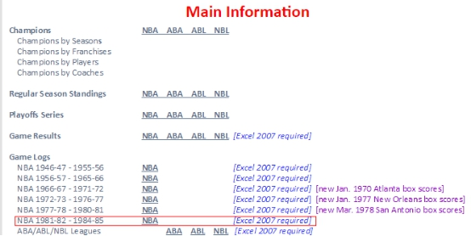

**Access & Use Information**

[Public:](" \l "accessLevel) This dataset is intended for public access and use.

**Interesting reason:** I think these data are popular for basketball fan especially who like to do some research of the important competition. This dataset link the fun and specific data analysis together, which I think is great.

**Potential data users and decision-makers for this data:** basketball tournament narrator; players themselves and their couches; basketball enthusiasts.

**Three questions this data might help to answer:**

1. Who in the one specific season (1981-82 - 1984-85) has the best FG (the total number of field goals made).
2. Which team played more stable.
3. Which team has the most potential.

3. Traffic violations

Traffic Violations. (2016, September 08). Retrieved September 14, 2016, from

<http://catalog.data.gov/dataset/traffic-violations-56dda>

**Access & Use Information**

[Public:](" \l "accessLevel) This dataset is intended for public access and use.

Non-Federal: This dataset is covered by different Terms of Use than Data.gov

**Interesting reason:** This issue is relevant to our daily life and life safety. Also, this dataset is very in detail.

Potential data users and decision-makers for this data: Governments or officials related to traffic management, control and rule makers; General people who care about driving safety especially those who live in Montgomery; automobile manufacturers and their agencies.

**Three questions this data might help to answer:**

1. Which specific area is easier to occur traffic violations.
2. What type of automobile is easier to break the traffic laws. In other words, which one has lower security level.
3. What action may lead drivers to severe accidents.

word count:460